**Create IBM DB2 And Connect With Python**

|  |  |
| --- | --- |
| Date | 15 November 2022 |
| Team ID | PNT2022TMID44798 |
| Project Name | SKILL/JOB RECOMMENDED APP |

**IBM DB2:**

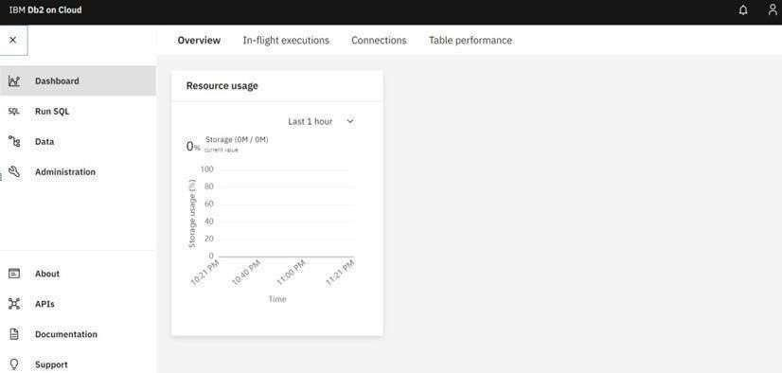

**DB2 with python:**

